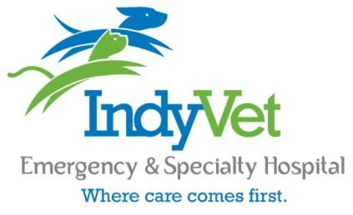
Veterinary Student Externship Program

IndyVet is a progressive specialty and emergency hospital that embraces a culture of mutual respect and teamwork while providing outstanding patient care and customer service. At IndyVet we put patient care first and believe in doing so through integrated clinical practice. Currently, we have specialists in critical care, surgery, internal medicine, neurology, oncology, and ophthalmology. We offer an externship program for veterinary students enrolled in their third or fourth years of veterinary school for rotations of one to six weeks in length to fulfill private practice or elective curriculum requirements.
At IndyVet we are committed to lifelong learning. Our objective is to educate veterinary student externs by providing learning opportunities that will build upon the extern’s knowledge base and clinical skills. We are a busy emergency and specialty hospital with high case load. Boarded specialists, experienced emergency clinicians, and interns are all involved in teaching visiting students. Veterinary Students participate directly with our clinicians in case management.

Ideal Candidates are:
- Third or fourth year veterinary students in good academic standing at an AVMA accredited school of Veterinary Medicine
- Looking for experience in an emergency and specialty practice
- Hard-working, motivated, friendly, and team oriented
- If you are considering an internship following graduation (particularly if you are considering application to IndyVet’s internship program) this would be a great learning opportunity
Externship Orientation:
Once scheduled, student externs will receive an orientation packet including mentorship, expectations, and schedule. Externs are expected to attend daily case rounds, as well as any grand rounds, journal club, and lectures that occur during their time with us. Any extern that is scheduled for 4 or more weeks is also required to give a case presentation for IndyVet staff. This usually occurs as a lunch presentation.

How to Apply:
Interested students should submit the following documents to krobertson@indyvet.com. Please include preferred dates for the externship and indicate which service(s) you would like to complete your externship with. If you would like to split your time at IndyVet between two or more departments we can accommodate that as well.
- Cover Letter | - Resume/CV | - School Requirements
Additional Information:
Housing
On-site housing is available if needed. Accommodations are provided at no charge to our externs.

Insurance
IndyVet does not require or provide professional liability insurance, health insurance, or worker’s compensation insurance for externs. If an extern’s university mandates that insurance coverage be obtained, it is the responsibility of the extern to arrange such coverage.

